III B. Tech I Semester Regular Examinations - December, 2023
MACHINE LEARNING
(CSE)

Time: 150 Min Max. Marks:80M

SECTION – A
Answer all Four questions 4×10M=40M

1. a) Recall the basic steps involved in training a supervised machine learning model?
- Analyse the results of a hierarchical clustering algorithm and discuss the implications of the dendrogram in understanding the relationships between data points.
c) Evaluate the goodness of fit of a linear regression model using appropriate metrics such as Least -squared and interpret the results in the context of the dataset
2. a) Justify need of Machine Learning algorithms for large data? State two such popular applications of ML?
b) Suppose 10000 patients get tested for flu; out of them, 9000 are actually healthy and 1000 are actually sick. For the sick people, a test was positive for 620 and negative for 380. For the healthy people, the same test was positive for 180 and negative for 8820.
Construct a confusion matrix for the data and compute the accuracy, precision and recall for the data?
c) From the following Diagram, identify which data points (1,2,3,4,5) are support vectors (if any) slack variables on correct side of classifier (if any) and slack variables on wrong side classifier (if any). Mention which point will have maximum penalty any why?
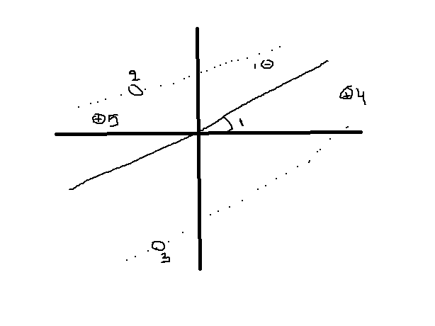
3. a) State any four types of regression methods?
b) Determine the regression equation by finding the regression slope coefficient and the intercept value using the following data.
x : 55 60 65 70 80
y : 52 54 56 58 62

c) Evaluate the appropriateness of linear regression in comparison to other regression techniques, such as polynomial regression or decision tree regression, for a specific dataset. Consider the dataset's characteristics, potential non-linear relationships, and the interpretability of the model. Discuss the strengths and limitations of linear regression in the given context and justify the choice of regression method based on the evaluation results.
4. a) What type of data requires to use decision tree? What are the components make up its structure?
b) Use ID3 algorithm to construct a decision tree for the data in the following table
Age | Competition | Type | Class (profit)
Old | Yes | Software | Down
Old | No | Software | Down
Old | No | Hardware | Down
Mid | Yes | Software | Down
Mid | Yes | Hardware | Down
Mid | No | Hardware | Up
Mid | No | Software | Up
New | Yes | Software | Up
New | No | Hardware | Up
New | No | Software | Up

c) Design a decision tree model for a hypothetical problem scenario. Consider factors such as the nature of the data, the desired outcomes, and potential complexities in the decision-making process. Create a step-by-step plan outlining how you would approach constructing and optimizing the decision tree for this specific problem.

SECTION - B
Answer all Two questions 2×20M=40M

5. Define clustering? The following data set using K-means Clustering for K=3 (i.e. 3clusters). The data set contains ‘1-Dimensional data and is as follows:
a) Use C1, (2), C2(16) and C3(38) as initial cluster centres
2
4
6
3
31
12
15
16
38
35
14
21
23
25
30

b) Analyse the results of k-Means clustering by visualizing the clusters in a scatter plot.
- Imagine you are tasked with applying k-Means clustering to a dataset that represents customer behaviour in an e-commerce platform. Design a novel approach to enhance the interpretability of the clusters for business stakeholders. Consider incorporating additional visualizations, descriptive statistics, or any creative elements to convey the characteristics of each cluster in a way that facilitates decision-making for marketing strategies.

6. a) Use naive Bayes algorithm to determine whether a red domestic SUV car is a stolen car or not using the following data:
Example no | Colour | Type | Origin | Whether stolen
1 | red | sports | domestic | yes
2 | red | sports | domestic | No
3 | red | sports | domestic | yes
4 | yellow | sports | domestic | No
5 | yellow | sports | imported | yes
6 | yellow | SUV | imported | No
7 | yellow | SUV | imported | yes
8 | yellow | SUV | domestic | No
9 | red | SUV | imported | No
10 | red | sports | imported | yes
b) Given an instance X of a feature vector and a class label ck, explain how Bayes theorem is
used to compute the probability P (ck ∣ X).
c) Implement a Naive Bayes classifier for sentiment analysis on customer reviews. Evaluate the performance of your classifier and suggest strategies to improve its accuracy. Consider discussing the impact of different features, the balance between precision and recall, and potential challenges in the dataset that may affect the classifier's performance.

